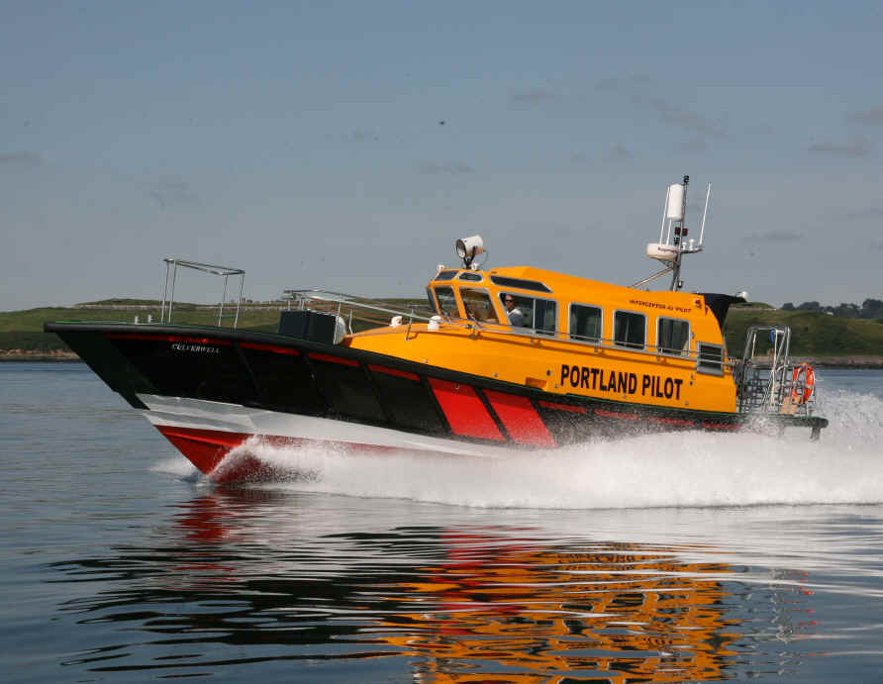

PILOTAGE
DIRECTIONS

Contents Page

Short Title 3
Commencement 3
Competent Harbour Authority 3
Area of Jurisdiction 3
Joint Pilotage Area 3
Vessels Subject to Compulsory Pilotage 3
Vessels Exempt from Compulsory Pilotage 4
Use of an Assistant Pilot 4
Pilot Boat Recognition & Boarding Points 4
Pilot Boarding & Landing in Adverse Weather Conditions 4
Non-Availability of Pilots 4
Responsibility of Masters 5
Procedure for Obtaining the Services of a Portland Harbour Authority Pilot 5
Vessels Over-carrying Pilots 6
Failure to take a Portland Harbour Authority Pilot 6
Reporting Misconduct of Portland Harbour Authority Pilots 7
Pilotage Exemption Certificates 7
Vessels Intending to use a Pilotage Exemption Certificate 10
Port Towage 11
Restricted Visibility 12
Schedule of Portland Harbour Authority Pilotage Directions 12
Communications with Portland Harbour Authority 13
Limitation of Liability 13

Pilotage Directions

The Portland Harbour Authority Pilotage Directions are made by Portland Harbour Authority, a Competent Harbour Authority within the meaning of the Pilotage Act 1987, in exercise of its powers under Section 7 of that Act.

Commencement

These Pilotage Directions supersede all previous Pilotage Directions and come into force on 1st January 2011 and remain in force until varied or supplemented by the Harbour Master of Portland Harbour Authority who will advise all necessary changes in writing, as and when required.

Competent Harbour Authority

Portland Harbour Authority Limited is the Competent Harbour Authority for the port of Portland Harbour.

Area of Jurisdiction

The area of jurisdiction for Portland C.H.A. is West of a line joining Grove Point (50 32.92N, 2 24.86W) and White Nothe, (50º 37.450’N. 02º 19.31’W), including Portland Inner and Outer Harbour but excluding Weymouth Harbour.

Joint Pilotage Area

The area within the line described above, not covered by Portland or Weymouth Harbours, and is a joint pilotage area between Portland Harbour Authority and Weymouth Harbour (See Annex A for chartlet).

Pilotage for all vessels proceeding west of a line joining Grove Point (50 32.92N, 02 24.86W) and White Nothe, (50º 37.450’N. 002º 19.31’W) but remaining outside the limits of Portland Harbour Authority and the Port of Weymouth will depend on local conditions and activity. All such vessels are to contact port control on CH 74 or 01305 824044.

Vessels Subject to Compulsory Pilotage

The following categories of vessels are subject to compulsory pilotage within the limits of Portland Harbour Authority Pilotage Area:

- Any vessel of 50 metres length overall and over.
- Any vessel of 20 metres length overall and over carrying any dangerous cargoes.
- Any vessel of 20 metres length overall and over carrying more than 12 passengers∗.

∗ "Passenger" means any person carried on a ship except:

- a person employed or engaged in any capacity on the business of the ship,
- a person on board the ship either in pursuance of the obligation laid upon the master to carry shipwrecked, distressed or other persons, or by reason of any circumstance that neither the master nor the owner nor the charterers (if any) could have prevented or forestalled,
- a child of under one year of age;

Section 1(2) Survey and Certification Regulations 1995 (SI 1210).

Pilotage is compulsory for the above vessels when the vessel is underway within the limits of Portland Harbour. Underway is defined as being not at anchor, or made fast to the shore or aground.

Vessels Exempt from Compulsory Pilotage

The following categories of vessels are exempt from compulsory pilotage by Portland C.H.A:

- RN vessels when not requiring the services of the ports towage unit/s.

- RFA vessels in the Outer Harbour, and the Inner Harbour north of a line between LATTICE TR. (50º 34.22N; 002º27.50W) and BEACON E (50º 34.79N:002º 24.81W).
- Any vessel transiting through the Portland Outer Harbour area to or from Weymouth Harbour that has an authorised Weymouth Pilot on board or a Weymouth Pilotage Exemption Certificate holder on board.
- Vessels departing from the Outer Harbour Anchorages (G1, G2, G3, G4, G5 and G6)

Use of an Assistant Pilot

The circumstances in which an authorized pilot in charge of a vessel is to be accompanied by an assistant who is also an authorized pilot, shall be determined by the Harbour Master, taking into account the size, characteristics of the vessel, its equipment, cargo, crew or the meteorological conditions.

Pilot Boat Recognition and Boarding Points

The Portland Harbour Authority Pilot Boat may be recognised by the legend ‘Portland Pilot’ in black letters on each side of the wheelhouse. There will not be a pilot boat permanently on station.

Unless a vessel has a pilot onboard when entering the Portland Harbour Authority Pilotage Area, Pilots shall normally be boarded and landed at:

- Inner 50º36.0’ N; 002º24.0‘W for vessels less than 180m LOA
- Outer 50º35.0’ N; 002º22.3‘W for vessels greater than 180m LOA

These positions are marked on Admiralty Charts 2268, 2255 and 2610.

Pilot Boarding and Landing in Adverse Weather Conditions

The boarding and landing of Pilots at the above locations is ‘weather permitting’. In adverse weather these boarding points may be altered in accordance with advice notified by Portland Harbour Radio.

Non-Availability of Pilots

Vessels for which pilotage is compulsory under the Pilotage Directions but for which no Pilot is immediately available, shall not navigate within the Portland Harbour Authority Pilotage Area without having obtained permission from the Duty Harbour Master.

Responsibility of Masters

The Master of a vessel having accepted the service of an authorised Portland Harbour Authority Pilot is required to facilitate his/her boarding and disembarkation and to comply with the Merchant Shipping (Pilot Ladders and Hoists) Regulations (Amendment) 1993 and IMO recommendations.

The Master of a vessel who has accepted the services of an authorised Portland Harbour Authority Pilot is required to declare its draught, length and beam, and to provide him/her with other information relating to the ship or its cargo as he/she requires and is necessary to enable the pilot to carry out his duties.

The Master of a vessel is required to bring to the notice of an authorised Portland Harbour Authority Pilot any defects in, and any matter peculiar to his/her ship and its machinery and equipment which might affect the navigation of the ship.

The Master of any vessel is required to sign the following Portland Harbour Authority forms before the act of pilotage commences:

- Pilot/Master Information Exchange Form
- Pilotage Service Return

Procedure for Obtaining the Services of a Portland Harbour Authority Pilot

Sufficient notice must be given for the services of a Portland Harbour Authority Pilot. Non compliance with the described ordering procedure may result in delay to the vessel or a surcharge.

Provisional Order

All vessels requiring the services of a Portland Harbour Authority Pilot must make a provisional order to Portland Harbour Authority at the Harbour Office. This includes inbound vessels, outbound vessels leaving a berth or anchorage or vessels shifting from a berth or anchorage to another.

The provisional order should be given 24 hours in advance and should provide the following details:

- Ship name
- IMO number
- MMSI number
- Call sign
- Last Port of call
- Next Port of call
- ETA
- ETD
- ISPS Security level
- Total number of persons onboard
- Maximum draught in metres
- Length, breadth, gross tonnage and ship type
- Thrusters
- Cargo on board
- Defects, damage, deficiencies, limitations
- Name, address and phone number of agent, captain or operator
- INF Ship Class (i.e. N/A, INF1, INF2, or INF3)
- Name, address, telephone/fax number, e-mail from which detailed information on the cargo may be obtained on request 24 hours a day

Vessels for which a provisional order is not received will not be prioritized and will therefore risk incurring delay.

Confirmed Order

Confirmation of the requirement for a Portland Harbour Authority Pilot must be given to Portland Harbour Authority at the Harbour Office.

Inward Bound Vessels

A confirmed order must be given 6 hours in advance of the vessel’s ETA at the pilot station.

Confirmation should again be given 2 hours in advance of the vessel’s ETA at the pilot station.

Outward Bound Vessels and Shifting Berth or Anchorage

A confirmed order must be given 6 hours in advance of the vessel’s ETD.

Confirmation should again be given 2 hours in advance of the vessel’s ETD.

Note:

- To avoid any misunderstanding of instructions, Portland Harbour Authority requires that the provisional order must be given in writing.
- Vessels are advised to copy to their agent all order information.
- A shorter notice than set out above may attract a surcharge and may result in delay to the vessel.
- At all times Portland Harbour Authority reserves the right to arrange the sequence of pilotage movements.
- A Portland Harbour Authority Pilot will not be dispatched to a vessel unless the 2 hours confirmation of ETA/ETD has been received or arrangements have been made.

Vessels Over-carrying Pilots

Vessels over-carrying Pilots must provide suitable accommodation, victuals and lifesaving equipment for the Pilot. No arrangements may be made with the individual Pilot.

Failure to take a Portland Harbour Authority Pilot

A ship which is being navigated within the area of jurisdiction of Portland Harbour Authority Limited as Competent Harbour Authority and which is subject to compulsory pilotage under this Direction must either be under the pilotage of an authorised Portland Harbour Authority Pilot or under the pilotage of the holder of a Pilotage Exemption Certificate holder for the area and ship. Section 15 of the Pilotage Act 1987 provides that if such is not so piloted, after an authorised Portland Harbour Authority Pilot has offered to take charge of that ship, the master of the ship shall be guilty of an offence.

Section 15 of the Act also provides that if the Master of a ship navigates his/her ship in an area and in circumstances in which pilotage is compulsory for it without notifying the Competent Harbour Authority that he/she proposes to do so, he/she shall be guilty of an offence.
Section 17 of the Act provides:

- An authorised Portland Harbour Authority Pilot may, within the area for which he/she is authorised, supersede as the pilot of a ship any unauthorised person who has been employed to pilot it.
- If the Master of any ship navigates it in any part of the area of jurisdiction under the pilotage of an unauthorised person without first notifying Portland Competent Harbour Authority that he/she proposes to do so, he/she shall be guilty of an offence.
- If an unauthorised person pilots a ship within the area of jurisdiction knowing that an authorised Portland Harbour Authority Pilot has offered to pilot it, he/she shall be guilty of an offence.
- If the Master of a ship navigating within the area of jurisdiction knowingly employs or continues to employ an unauthorised person to pilot his/her ship after an authorised Portland Harbour Authority Pilot, has offered to pilot it he/she shall be guilty of an offence.

In addition to the possibility of prosecution a penalty charge will be levied.

Reporting Misconduct of Portland Harbour Authority Pilots

Any incident involving misconduct or unsatisfactory performance of an authorised Portland Harbour Authority Pilot should be forwarded to Portland Harbour Authority Limited without delay.

The Report is to be made in writing to:

The Portland Pilotage Committee
Portland Harbour Authority Limited
Port Office
Castletown
Portland
Dorset
DT5 1PP

Tel: +44 (0) 1305 824044
Fax: +44 (0) 1305 826143

Pilotage Exemption Certificates (PECs)

General Principles

- The requirements of a Pilotage Exemption Certificate (PEC) system are outlined in Section 8 and 15 of the Pilotage Act 1987.
- Chapter 2.6 of the Port Marine Safety Code relates to the powers and duties which Harbour Authorities have to exempt certain ships officers from their requirements to take an authorized pilot. The use of these powers should follow these general principles:
  - The standards for PECs must not be more onerous than those required for an authorized pilot; but they should be equivalent.
  - PEC Holders and their Employers are accountable to the issuing Harbour Authority for the proper use of any Certificate.
  - Harbour Authorities should have formal written agreements with PEC Holders and their Employers to regulate the use of Certificates.

Issue of a PEC

A PEC will be issued to bona fide Masters and First Mates (‘Bona Fide First Mate’ means the person signed on the ships articles who will take command in the event of the master being indisposed) of any vessel, for use in the Portland Harbour Pilotage Area, if they satisfy the following conditions:

- All Applicants have a valid STCW Certificate of Competency or other appropriate marine qualification appropriate to the size, type of vessel and rank on which they are serving and valid medical certificates.
- Applicants must notify Portland Harbour Authority of their intention to start the process of gaining a PEC. In response Portland Harbour Authority will send to the Applicant a PEC Information / Application Pack.
- All Applicants must be able to communicate clearly and effectively using English Language, by VHF Radio.
- Applicants must complete a qualifying number of trips before undertaking a pilotage assessment and examination. An applicant must have completed at least 12 passages of pilotage in the 6 months immediately prior to the application with an authorised Portland Pilot, of which no less than 8 must be in daylight and no less than 4 in darkness. A tug(s) (if applicable), must be used during one daylight and one darkness passage.
- The qualifying trip requirements for passenger carrying vessels between 20m LOA and 30m LOA are relaxed such that the applicant will only be required to undertake one entry and exit of the breakwaters prior to undertaking the oral examination; this approach has been justified by formal risk assessment. Any PEC issued under this provision is only valid during daylight and when the visibility exceeds 1 mile. After sunset and before sunrise and in restricted visibility the PEC will not be valid and a pilot must be taken. Any PEC certificate issued under this provision will be endorsed with these limitations.
- Qualifying trips for a PEC can only be undertaken in the presence of an authorized Portland Pilot.
- Applicants must complete their qualifying trips in the vessel for which the PEC will be eventually used. Exceptions for this requirement can only be made by prior arrangement with Portland Harbour Authority.
- Applicants must be present on the bridge throughout the duration of the qualifying trip. The applicant must have understudied the pilot and had effective responsibility for the conduct of the vessel during the trip. Applicants should record all details of their trip on the tripping record form. These details will be witnessed and countersigned by the authorized Portland Pilot.
- Prior to examination and assessment the Applicant must have visited the Harbour Control Office of Portland Harbour Radio.
- On completion of the required number of qualifying trips, applicants should submit their application using the prescribed forms:
  - Applicant’s Application
  - Applicant’s Tripping Log
  - Copy of the Applicant’s valid Certificate of Competency or other appropriate marine qualification
  - Copy of the Applicant’s valid medical Certificate
  - Appropriate fee
- Each Applicant will undergo an oral examination conducted by the Harbour Master or his deputy and an authorized Portland Pilot. Examinations will be conducted in such places and at such times as Portland Harbour Authority may direct. The examining panel is to be satisfied by the local knowledge of the Applicant.
- Each Applicant will undergo an assessment by an authorized Portland Pilot, onboard the vessel to which the PEC application applies. The Pilot is to be satisfied as to the relevant skills and experience of the Applicant.
- A successful Applicant will be granted the benefit of a Portland Pilotage Exemption Certificate whether they choose to use it or not. A failed certificate will not be re-examined until at least a month after the date of failure; after second and subsequent failures, candidates will not be re-examined until at least three months have elapsed from the date of the last examination.

Use of a PEC

- A PEC may only be used by the bona fide Master or First Mate of any vessel.
- A PEC may only be used on the vessel(s) named on the PEC.
- A PEC Holder shall not allow any other person to have possession of, or make improper use of the Pilotage Exemption Certificate.
- A PEC Holder shall be on the bridge at all times when conducting an act of pilotage throughout the Portland Harbour Authority Pilotage Area.
- A PEC remains valid for one year from the date of issue or renewal. The expiry date of the PEC is clearly indicated on the Certificate. It is the responsibility of the PEC Holder to ensure that his/her PEC remains valid.
- A PEC will only remain valid as long as the Holder’s Certificate of Competency and Medical Certificate are also valid.
- PEC Holders shall have their certificates available for inspection at all times when in the Portland Harbour Authority Pilotage Area.

Contractual Agreement

Portland Harbour Authority will require a contractual agreement with the Owner or Operator of the vessel regarding the management of navigational on board the vessel and the operating procedures relating to the use of the PEC.

- The Contractual Agreement is a requirement of the Port Marine Safety Code.
- Contractual Agreements are issued to all Applicants for a PEC to forward to the Operator of their ships. Portland Harbour Authority will not issue a PEC until a completed Agreement has been returned.
- The purpose of the Contractual Agreement is to:
  - Regulate the procedures and obligations relating to the use of Pilotage Exemption Certificates in respect of Portland Harbour Authority, the vessel Operator and the PEC Holder.
  - Determine who is legally responsible for the operation of any ship on any given Portland Harbour Authority Pilotage Exemption Certificate.

Annual Renewal of a PEC

- A PEC is issued for a period of 12 months. Failure to renew a PEC leads to its expiry.
- The Applicant must have completed at least 6 acts of pilotage, 1 act of pilotage for passenger carrying vessels between 20m and 30m LOA, in the Portland Harbour Authority Pilotage Area for renewal.
- It is the responsibility of the PEC Holder to ensure that a fully completed application for renewal is received by Portland Harbour Authority no later than one month before the expiry of the PEC.
- The application must be accompanied by proof of the Applicant’s ongoing Competency, medical fitness and the appropriate fee.

Reinstatement of an Expired PEC

- The criteria for reinstatement of an expired PEC will, under normal circumstances are as for a new application.
- If the Applicant can show extenuating circumstances, upon request, Portland Harbour Authority may consider an extension to the renewal deadline.

Five-Yearly Re-Certification

- No PEC will be renewed after each five year period unless the PEC Holder has, within the fifth year, satisfied Portland Harbour Authority by assessment and examination to his/her continuing skill, experience and local knowledge.
- It is the responsibility of the PEC Holder to ensure that Portland Harbour Authority is contacted to arrange the assessment and examination during the fifth year of the PEC prior to its expiry.

Suspension or Revocation of a PEC

- Portland Harbour Authority may suspend or revoke a PEC granted by it under Section 8(6) of the Pilotage Act 1987 if it appears that the PEC Holder has been guilty of any incompetence or misconduct affecting his/her capability to pilot the ship of which he is a deck officer or any other ships specified on the PEC.
- Before suspending or revoking a PEC, Portland Harbour Authority shall give the PEC Holder written notice of its intention to do so, stating the reasons for which it proposes to act, and shall give the PEC Holder a reasonable opportunity of making representation.
- Portland Harbour Authority shall immediately suspend or revoke a PEC granted by it under Section 8(6) of the Pilotage Act 1987 if it appears, or in the view of the Harbour Master, the PEC Holder has been guilty of gross incompetence or gross misconduct affecting his/her capability to pilot the ship of which he/she is a Deck Officer or any other ships specified on the PEC, and thus minimising the risk of the safety of navigation being further compromised.

Charges for Portland Harbour Authority Pilotage Exemption Certificates

- Examination / Assessment and Issue £ 200
- Re-examination Only £ 100
- Annual Renewal of Certificates £ 50
- Amendment of Certificates £ 50

Vessels intending to use Pilotage Exemption Certificates

The Harbour Office at Portland Harbour Authority must be notified 24 hours in advance for vessels normally trading from outside the Portland Harbour Authority Pilotage Area which are subject to compulsory pilotage and intend to employ a PEC holder. Such notice must include:

- Vessel Name / Call Sign / MMSI / IMO Number
- LOA
- GRT
- Max Draft
- Surname / Forename of PEC Holder
- ETA/ETD

If this information is not provided, the vessel may be required to use the services of a Portland Harbour Authority Pilot and this could involve the vessel in a delay as well as a surcharge.

All Portland Harbour Authority Pilotage Exemption Certificate holders are to complete the Tripping Form and forward to the Harbour Master at the end of each calendar month with the details of the occasions he/she has piloted their vessel of which he/she is a deck officer when an authorised Portland Harbour Authority Pilot has not been employed.

A charge will be levied on each occasion to any vessel that is being piloted within the Portland Harbour Authority Pilotage Area by a Deck Officer who is the holder of a Portland Pilotage Exemption Certificate in respect of that ship.

Port Towage

The Port has three Harbour tugs 22, 50 and 55 tons bollard pull which are available for assisting in manoeuvring and berthing.

Ship’s Masters and Pilotage Exemption Certificate holders are encouraged, in the interests of safety to use towage assistance when in any doubt.

Compulsory Towage in Portland Harbour

This Direction is given for the purpose of safety of navigation and the safety of persons and property in the harbour and shall apply at all times.

A Master of any vessel may request the assistance of a tug or tugs at any time.

For single screw vessels not fitted with manoeuvring aids the use of a tug, or tugs, is compulsory for the following movements:

- Vessels Entering/Leaving Harbour To/From Inner Harbour Anchorage

  - 200 – 280 metres LOA 2 Tugs
  - 180 – 200 metres LOA 1 Tug

- Vessels Entering/Leaving Harbour To/From Alongside Berth

- 120 – 200 metres LOA 2 Tugs
- 100 – 120 metres LOA 1 Tug

Masters of vessels fitted with twin-screws and/or other manoeuvring aids are directed to use a tug or tugs as considered appropriate having considered the advice of the pilot.

Failure to comply with this Direction is an offence and offenders may be prosecuted.

Restricted Visibility

The following restrictions will apply to vessels of more than 20m LOA when visibility is reduced to less than 2.5 cables.

- A vessel will not be permitted to get under way from a berth or an anchorage or move within the port limits unless it has an operational VHF radio on channel 74.
- Vessels will not be permitted to pass through North Ship Channel or East Ship Channel or enter the “controlled area” area unless the vessel has fully operational radar.

When conditions are marginal the Pilot and Master, after full appraisal of the situation, should decide on continuing the operation or not. The Pilot should make him/herself aware of conditions along the planned route, at the berth and amend passage plan as required.

Schedule of Portland Harbour Authority Pilotage Charges

Charges for Acts of Pilotage (2016 Standard Port Tariff)

Standard Rate Shifting Within the Harbour

£4.65 per metre LOA 50% of Standard Rate

Vessels operated by the General Lighthouse Authorities and Royal Naval vessels will be charged at a rate of 50% of the standard rate.

For Index Berthing serials a charge of twice the standard 50% rate will be made.

Pilotage charges are levied per act.

Tug and Tow

For charging purposes the LOA shall be deemed to be the LOA of the longest vessel when towed alongside or the combined LOA’s of the tug and the towed vessel when towing astern.

Charges for Acts of Self Pilotage

If a Pilotage Exemption Certificate is held the Pilotage charge levied will be at the rate of 35% of the standard rate per trip.

Penalties

If less than 6 hours notice of a request for Portland Pilotage services is received a penalty charge of 25% of the Standard Charge will be levied.

Cancellation of a request for Portland Pilotage services or an amendment to an ETA/ETD received up to 2 hours before the time for which the request was made will be accepted without charge.

If after the 2 hour notice has been received a request for Portland Pilotage services is subsequently cancelled or amended a fee of 50% of the Standard Charge will be charged.

If a Portland Pilot has attended a vessel or the pilot boarding position for the time requested and the act of pilotage has not commenced within 30 minutes of that time the request for services will be cancelled automatically and a cancellation fee of 50% of the Standard Charge will be charged.

Once an act of pilotage has commenced, if for any reason the vessel’s transit is delayed for 30 minutes or more, then a detention fee of £50 will be charged for each period of 30 minutes or part thereof after the first 30 minutes of the delay.

The over carrying of a Portland Harbour Authority Pilot will incur a charge of £200 per 24 hour period or part thereof until the pilot is returned to Portland. In addition the costs of repatriation to Portland will be charged against the ship.

Failure to take a Portland Pilot may result in prosecution; also a charge of twice the standard pilotage charge for the vessel may be levied.

If a vessel is unable to reach the destination for which the services of a Portland Pilot have been engaged, through any circumstances, a charge shall be made equivalent to that payable for the Act of Pilotage.

An Act of Pilotage shall be deemed to be completed once a vessel has secured at a safe berth or anchorage within the area, or has departed from the area of jurisdiction of Portland Harbour Authority Limited as Competent Harbour Authority.

Penalties may be waived in extenuating circumstances or in consideration of adverse weather conditions or poor visibility.

Communications with Portland Harbour Authority

Portland Harbour Authority Harbour Office
Portland Port
Castetown
Portland
Dorset
DT5 1PP

Telephone: +44 (0) 1305 824044
Fax: +44 (0) 1305 826143
E-mail: eta@portland-port.co.uk
VHF Channel 74
www.portland-port.co.uk

Limitation of Liability

Portland Harbour Authority shall not be liable for delays arising from its failure to provide a pilotage service. This applies whether the failure and/or delay is the result of force majeure, including industrial action, adverse weather, security incident or from any other cause whether within the control of Portland Harbour Authority or not.

Portland Harbour Authority shall not be liable for loss or damage caused by its acts or omissions in respect of provision of a pilotage service except where statutes imposing strict liability may otherwise provide.

Annex A.

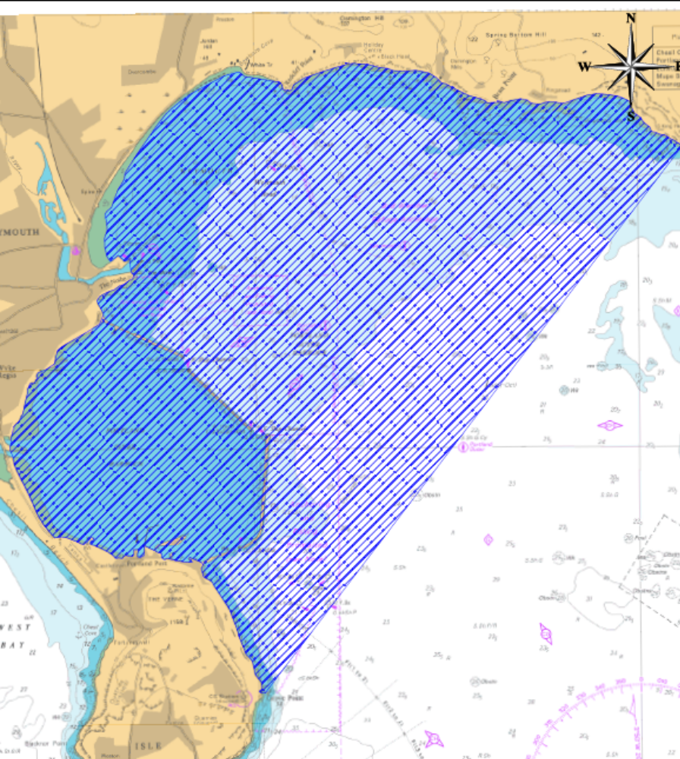

Portland Harbour Authority CHA, Area of Jurisdiction.

