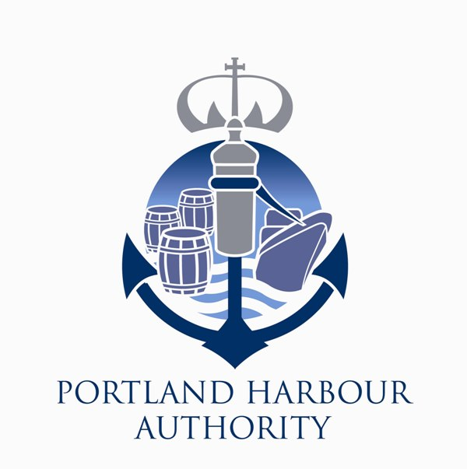
PORTLAND HARBOUR AUTHORITY LIMITED

Local Notice to Mariners

No 37/2017(T)

EAST SHIP CHANNEL PORT TRAFFIC SIGNALS

The top red light on the Port Traffic Signal Station, situated on Fort Head, for East Ship Channel (on chart BA2268), is extinguished until further notice.

This notice is issued under the powers vested by the Portland Harbour Revision Order 1997.

Captain M Shipley
General Manager (Marine)
29th September 2017

Owners, Agents, Yacht Clubs and Recreational Sailing Organisations should ensure that the contents of this notice are made known to the Masters or persons in charge of their vessels or craft.

